Group Members: Katherine Ruiz, Stevie Bien, Chad Farrington

Database SQL installation script file name:

phpMyAdmin User Account SQL script file name:

To install the Database SQL script:

* Go to browser and enter localhost/phpMyAdmin  
  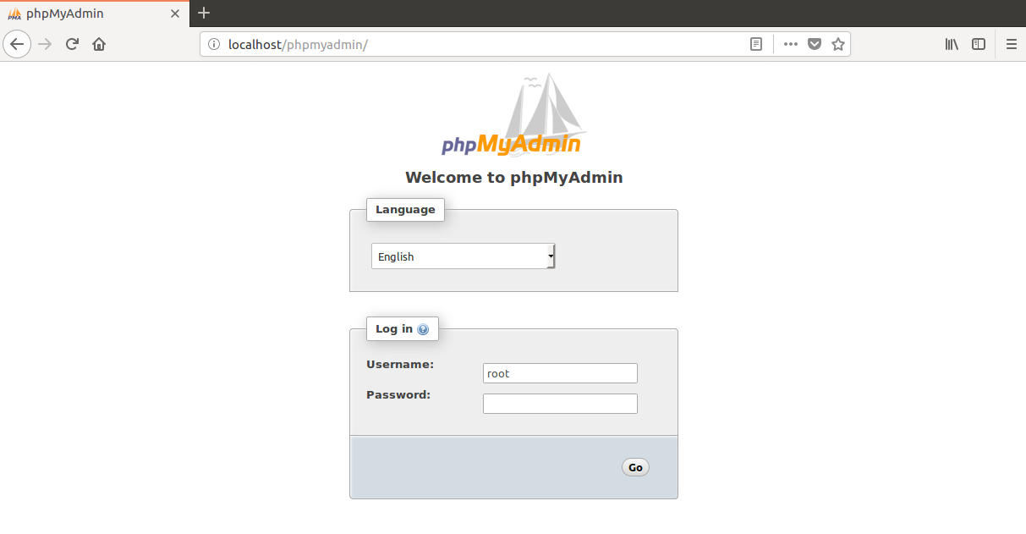
* Sign in with the user account you have (usually root), whether you have implemented a password (usually password) and proceed to the main dashboard of phpMyAdmin  
  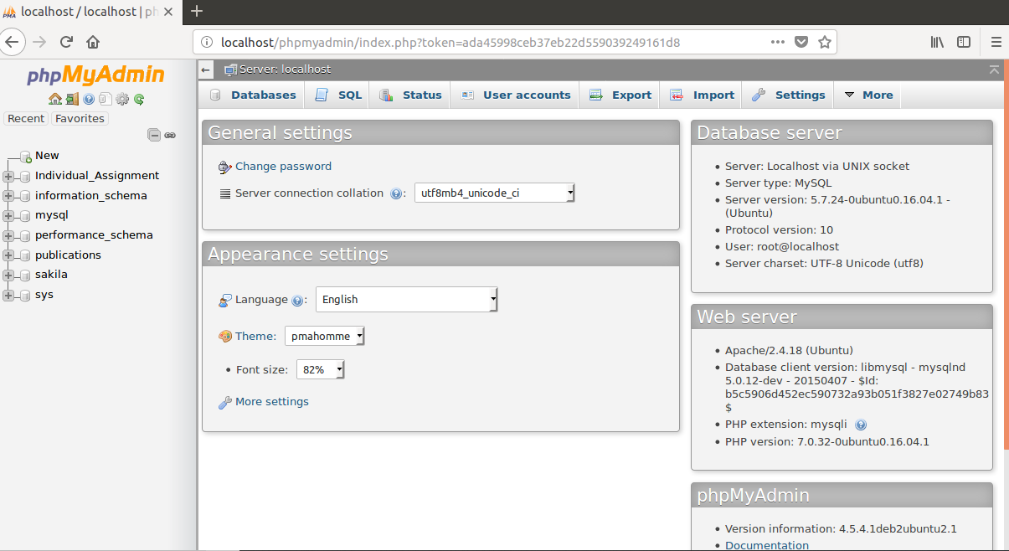
* Click on the Import tab  
  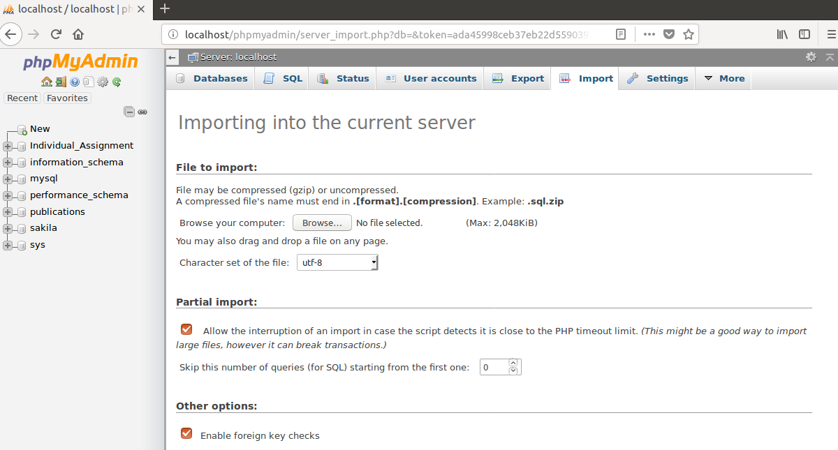
* Click the Browse button and select mdc_techclub_db final.sql and click on the Go button on the bottom of the page  
  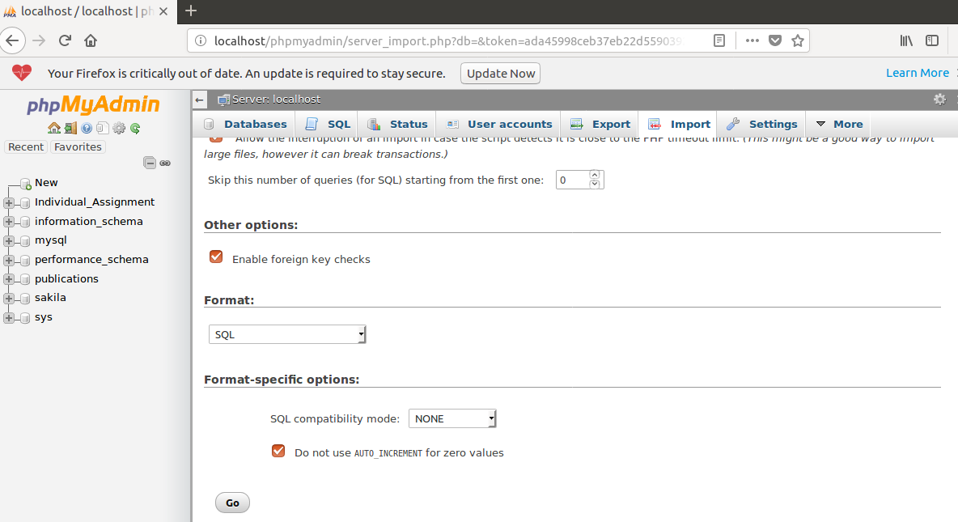
* From there, the mdc_techclub_db Database should be created as well as the records will have populated the tables   
  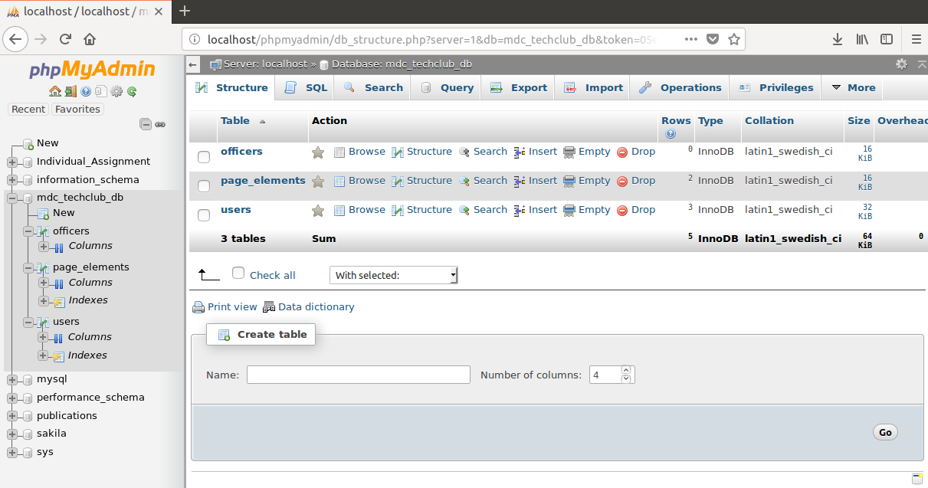

To install the phpMyAdmin User Account SQL script:

* Click the Import tab again and select the user.sql file. Select the Go button at the bottom of the page.
* From there, the user User Account should be created and the privileges will have already been set with the account.   
  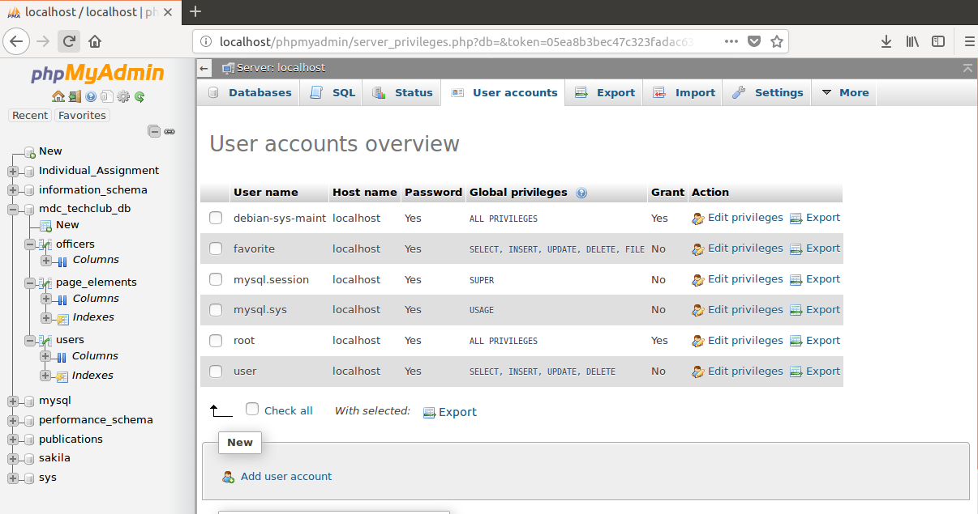  
    
  You should have the ability to log in to said user account through phpMyAdmin’s log in page. The password is password.